Staff Council Meeting Minutes
February 9, 2022 | Wednesday | 1:00pm | ONLINE (Zoom)
Participants: Professional Staff of University of Hartford

Welcome: Dr. Kate Darcy Hohenthal, Staff Council Chair
- Reminder: If anyone has concerns about anything, please bring them to the attention of Staff Council so we may feature guest speakers at upcoming meetings

Guest Speaker: Lisa Langsner, Director, Jewish Student Life & Hartford Hillel
- 650-700 Jewish students on campus
- Nearly 1/3 of Jewish students across the U.S. report having experienced some form of anti-Semitism in the past year
- Expressed appreciation for moving the September 2021 general meeting to accommodate Rosh Hashanah as this is inclusive of the Jewish community

Guest Speaker: Jeffrey Findlay| Aramark | Resident District Manager Facilities
- For routine services or requests, or emergency situations, members of the campus community should submit a new work order through WebTMA
  - Web TMA generates a new work order, tracks the order, and provides details on the status of the order
  - Employees can use the QR code below/online to be directed to the online work order system.
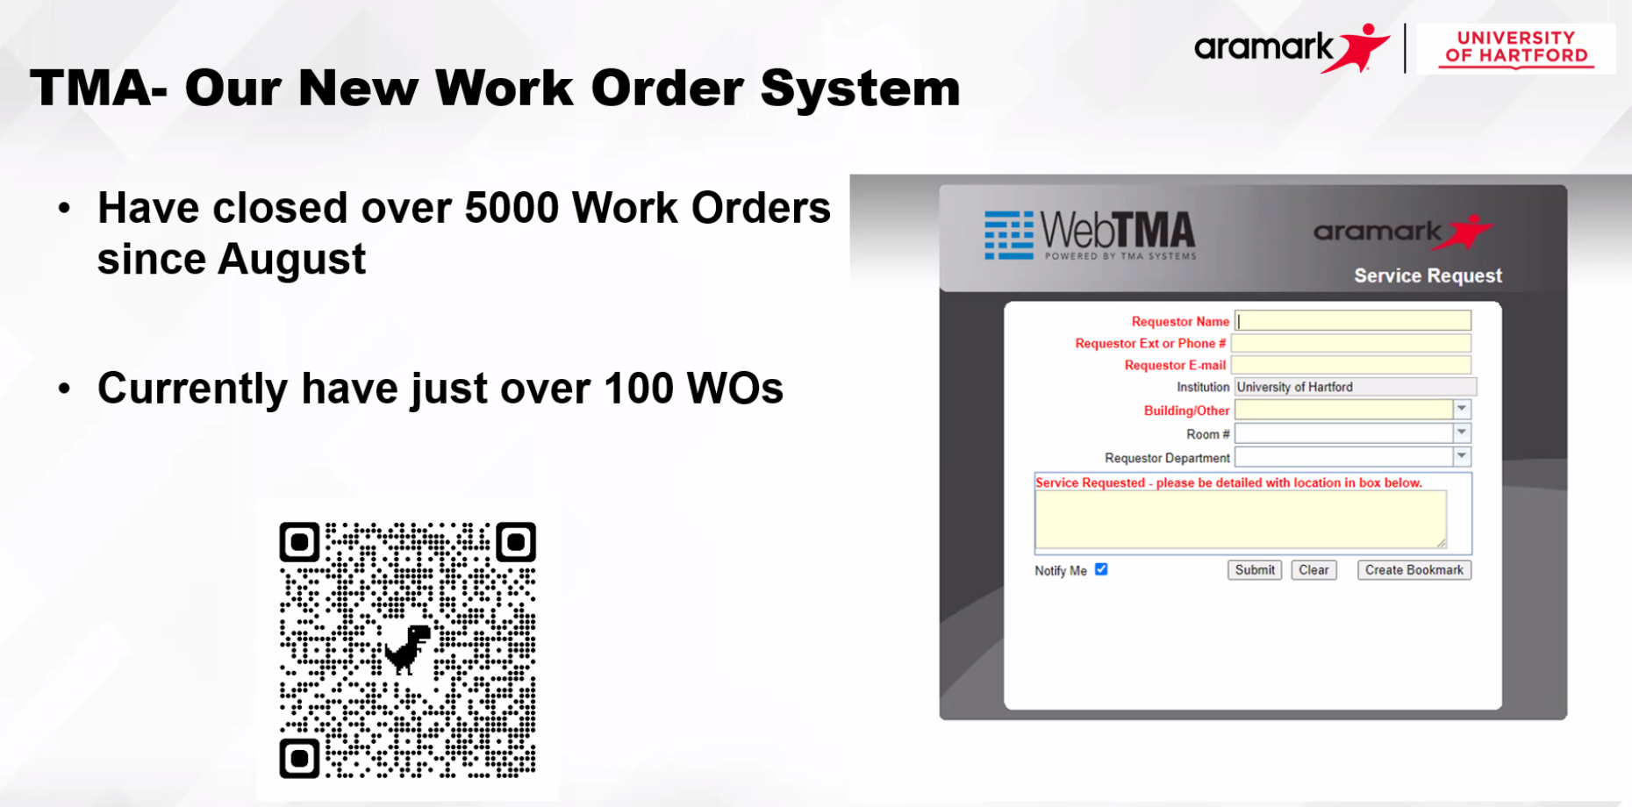
- Routine services will not incur any charges
- Since August 2021, 5,000 work orders have been completed and closed for the campus community
- Facilities has piloted a new feature in restrooms in a couple of campus buildings – this is still in the preliminary phases to be able to service restrooms during peak usage
- Highlights of completed projects include: Glaze Room project in the Art School; East Hall carpet cleaning and gender-neutral restroom installation; enhancements made in the 1877 Club; HPAC Lighting; Data/UT renovations and painting project; Injector pump replacement at Harry Jack Gray Center; Turned over 165 rooms for spring semester move-in; Contracting with Butler to treat campus roads during snow season; Campus lighting refresh
- Future projects include: Blue emergency call boxes additions to HPAC, Athletics, and Villages; Additional lighting in HPAC and main campus; Tennis court renovations; Admissions second floor carpets; Painting in Hillyer Hall (4th floor and work way down); Commencement logistics; Summer Recovery plan (cleaning, refreshing spaces, etc.)
- Brief update on GSU next steps after pipe burst and overall aesthetic renovations: Priority is getting CSS employees back in their original space by end of February, replacing North cafeteria carpet, ensuring the pipes are up-to-par so this does not reoccur.
- Recycling program exists and will likely be evaluated and updated in the future; Currently there is a task force focusing on sustainability in general
- Contact Jeff with any questions at Findlay-Jeffrey@aramark.com or FINDLAY@hartford.edu

January 12, 2022 - General Meeting Minutes
- Discussion and approval of the minutes from previous general meeting
  - Laurie Fasciano voted to approve the Minutes as written; Marsha Gaulin seconded this motion
  - Approved with 19 votes in favor and 1 abstention vote

Delegate Reports

Treasurer’s Report: (Linda Zigmont) Balance is $1,422.98
  - No change

Benefits Taskforce: (Cindy Oppenheimer/Desirée Kleykamp)
- No change

Resource Planning & Priorities Committee (RPPC): (Laura D’Angelo-Gohn/Ben Ide)
- The Resource Planning and Priorities committee (RPPC) met on Thursday Feb. 3rd with guest speaker President Woodward. The President delivered a presentation that he intends to propose to the Board of Regents, outlining several key areas of Financial Responsibility that he hopes the University will be able to put in motion over the next 3 years. President Woodward has delivered and will continue to deliver this presentation to all seven colleges and major organizations in the campus community.

Fundraising
- No Change

Ways and Means (Ben Ide)
- No change

Faculty Senate: (Rachel Yacouby)
- No change

Diversity, Equity, and Inclusion Task Force (Desirée Kleykamp/Lisa Cote)
Register for upcoming events at the links below:
- Black History Month programs: https://www.hartford.edu/about/diversity-inclusion/mlk-observance.aspx#BHM
- The Women's History Month Programs: https://www.hartford.edu/unotes/2022/02/mark-your-calendar-for-womens-history-month-2022.aspx
- Rogow Distinguished Panel Discussion: https://www.hartford.edu/unotes/2021/12/rogow-distinguished-visiting-lecturer-series-presents-a-panel-discussion-on-building-resilience-and-connection.aspx

“Only the Ball Was White”: The Negro Leagues and Their Place in American History
- Wednesdays, February 2, 9, and 16, 7-8:15pm
- Baseball both reflects American culture and helps to shape it. Please note: This program has a $60 fee for off-campus participants.

Activism through Action: Moving Beyond a Hashtag
- Friday, February 18, 2022, 12:45-1:45pm
- Guest Speaker: Zyahna Bryant

From Martin Luther King to Nelson Mandela: The Global Vocabulary of Black Liberation
- Monday, February 21, 2022, 12:45-1:45pm
- Guest Speaker: Dr. Garrey Dennie
- Martin Luther King and Nelson Mandela stand as iconic figures in the struggle against racial oppression.

The Georgette and Richard Koopman Distinguished Chair in the Visual Arts Exhibition presents illustrations by Floyd Cooper
- February 24, 2022 – March 24, 2022
- Joseloff Gallery

Women’s History Month: Celebrating 50 Years of Title IX (via Zoom)
- March 1 from 6:30-7:30pm
- Panelists: Congresswoman Jahana Hayes, Dr. Estela López, and Dr. Sharon Beverly; moderators: Dr. Annette Rogers and Hannah Arasim

Reclaiming Equity: Indigenous Women, Power, and Place
- March 3 from 1:00-2:00pm
- Guest Speaker: Endawnis Spears
International Women’s Day: Standing Up and Breaking Through
- March 8 from 1:00-2:00pm
- Guest Speaker: Dr. Mariko Silver
Conversation about The Chair
- March 29 from 1-2:30pm
- Facilitators: Peggy Beauregard & Carolyn Pe Rosiene
- Location: Shaw Center; register here

Rogow Distinguished Visiting Lecturer Series: Building Resilience and Connection: An Antidote in Challenging Times
- Thursday, March 31, 2022, 6:30-7:30pm
- Panelists: Dr. Noel Casiano, Najeia Mention, Frances Padilla; moderator: Dr. Jessica Nicklin

Community Representative Reports

Barney School of Business Sally Wang
- Khalia Whyte joined Barney as the new Manager of Undergraduate Admissions and Services.
- Barney Leadership Council will host a virtual event with Michael Daglio, Executive VP and COO of Hartford Healthcare on Feb.18th. Please share this with your students who might be interested.
  - https://www.hartford.edu/unotes/2022/02/an-event-with-michael-daglio-.aspx

Hartford Art School | Marsha Gaulin
- Reminder- There are benefits to UHart staff for the Wadsworth Atheneum Museum of Art: Free admission for students, faculty, and staff. Additional $3 fee for all visitors during the Festival of Trees & Traditions. Must show University ID. This also applies to the New Britain Museum of American Art as well!
- The Alexander A. Goldfarb Juried Student Exhibition is running through Feb. 12 in Joseloff Gallery. Two students were selected to win a $1000.00 prize- Anastasia Mulinski and Desmond Cleary :
The Alexander A. Goldfarb Juried Student Exhibition is an annual event hosted by Hartford Art School. This juried exhibition provides ALL University of Hartford students have an opportunity to submit work for exhibition at the Joseloff Gallery.
GOLDFARB HISTORY
In the late-1980’s, the Alexander A. Goldfarb Memorial Trust was created at the University of Hartford to honor the late Alexander Goldfarb and his dedication to the arts. This trust would fund the Juried Student Art Exhibition—as it was then called—to be held annually at the Joseloff Gallery.

Office of Career and Professional Development | Kate Darcy Hohenthal
- Virtual Career Summit March 1-3
  - LinkedIn Event hosted by Women’s Advancement
  - Career Fair
  - Employer events
- Resume Boot Camps February 23-25

Office of Marketing & Communications | Lawrence Rosado
- There will be faculty/staff headshot photoshoots on Monday 2/21 1:00–5:00pm in the Library and Tuesday 2/22 8:00am–Noon in the Library
  - These sessions are full at this time, but there will be future opportunities

Upcoming Staff Council Meetings
- President Greg Woodward will join us 3/9/22
- April 6, 2022
- May 11, 2022

